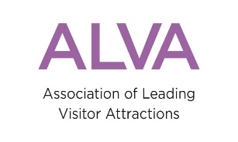
BOOKING FORM
Theatre Performance & Art in Attractions Conference
15th March 2018
RAF Club, Piccadilly, London
£192 per person (£160 +VAT) for individuals of ALVA member organisations. £300 (£250 + VAT) for non-members.
Price includes lunch and refreshments

Delegate Information

First Name: Last Name:
Job Title: Organisation:
(This information will be used on your name badge)
Contact Details
Email address: Telephone:
Dietary and access requirements:
Payment Information
Cheques: Please make payable to “ALVA”
Bank Transfer: ALVA Sort Code: 56-00-33 Account Number: 10217797 (Please quote THEATRE/Surname)
☐ I enclose a cheque for £
☐ I have paid £ by Bank Transfer on (quote THEATRE/Surname)
☐ I would like to be invoiced
Name on Invoice:
Address on Invoice:
Email address to send invoice to: PO number (if required):
☐ Please tick the box to validate your booking. I agree to the booking outlined above and understand that cancellations must be made in writing to the address below and are subject to the following surcharges: More than 28 days’ notice - 75% of total; less than 28 days - 100% of total.
Please return your completed form to: Events Manager: Barbara Commons
As an attachment to: bcommons@alva.org.uk Post to: ALVA, New Wing, Strand, London, WC2R 1LA

